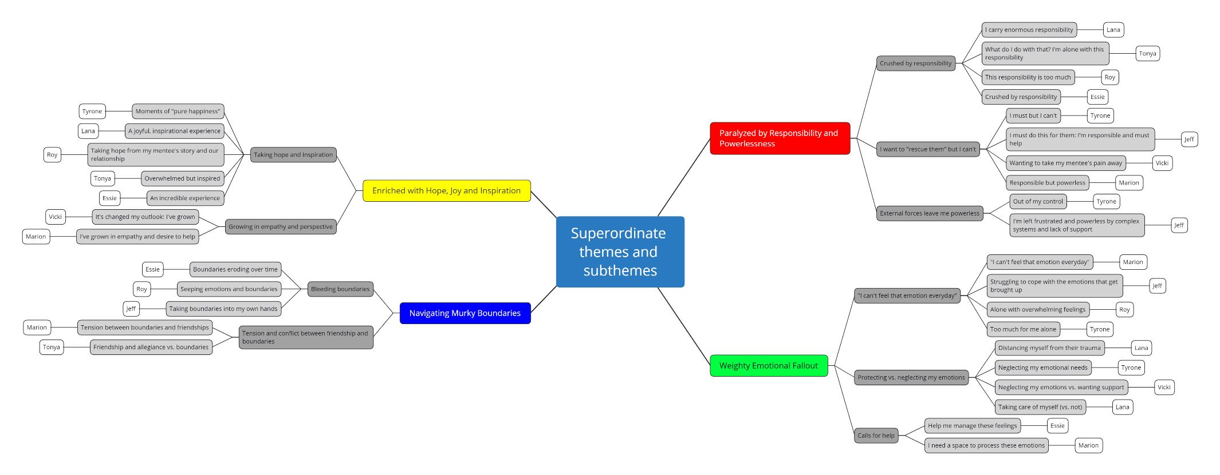
Appendix. Superordinate and subordinate themes for the group, indicating participant contributions

